Use Newton’s method to find the zeros of $x-\frac{f(x)}{\begin{aligned}f^{'}\left(x\right) \\ \end{aligned}}$
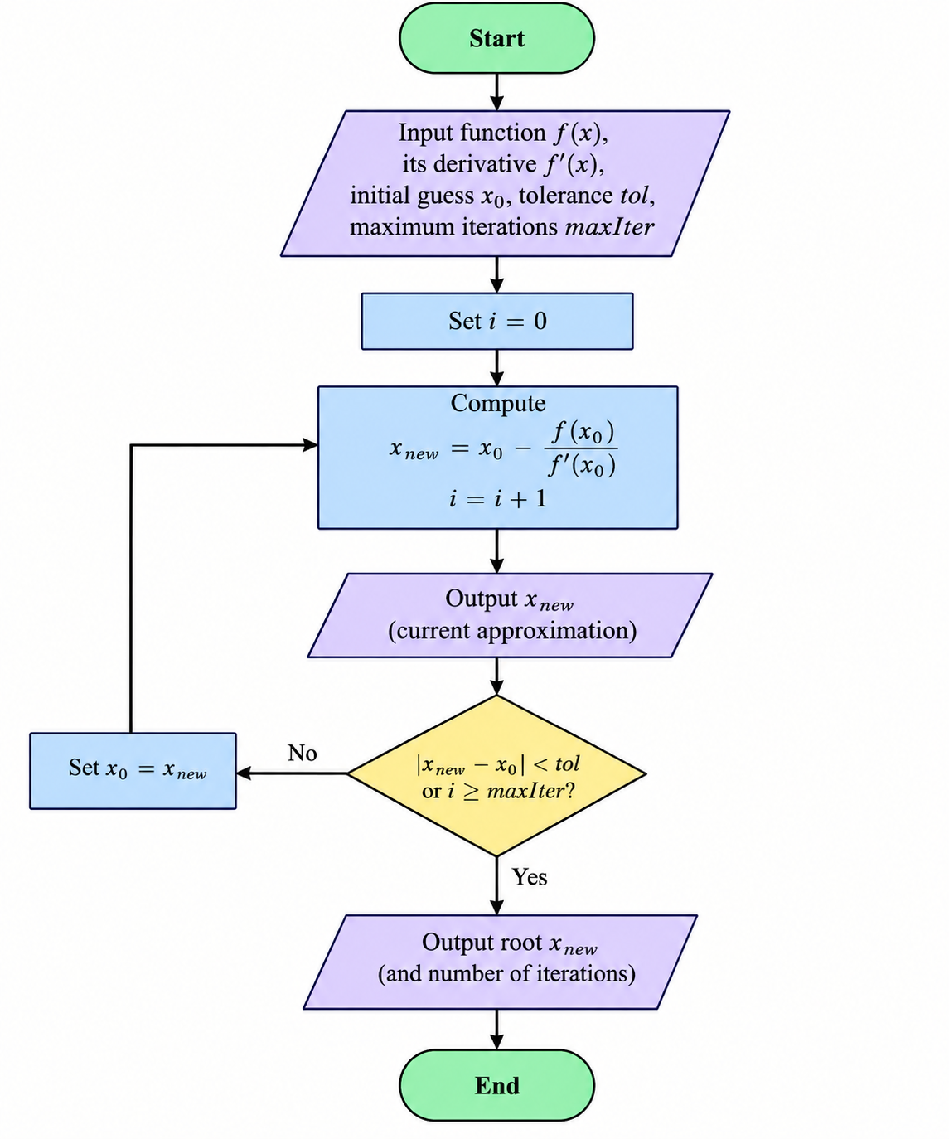

MATLAB CODES
clc;
clear;
close all;

% Define the function f(x)
f = @(x) x^3 - x - 2;

% Derivative of f(x)
df = @(x) 3*x^2 - 1;

% Initial guess
x0 = 1.5;

% Tolerance
tol = 1e-6;

% Maximum number of iterations
maxIter = 100;

% Newton-Raphson iteration
fprintf('Newton''s Method\n');
fprintf('---------------------------\n');
fprintf('Iteration x\n');

for i = 1:maxIter

% Newton formula
x1 = x0 - f(x0)/df(x0);

fprintf('%5d %.10f\n', i, x1);

% Check convergence
if abs(x1 - x0) < tol
break;
end

x0 = x1;
end

fprintf('\nRoot = %.10f\n', x1);
fprintf('Number of iterations = %d\n', i);

% Plot the function
x = linspace(-3,3,500);
y = f(x);

figure;
plot(x,y,'LineWidth',1.5);
hold on;

% x-axis
plot(x,zeros(size(x)),'k--');

% Root
plot(x1,f(x1),'ro','MarkerSize',8,'LineWidth',2);

grid on;
xlabel('x');
ylabel('f(x)');
title('Newton''s Method');
legend('f(x)','x-axis','Root');

PSEUDO CODES
Define f(x)
Define f'(x)

Input initial guess x0
Input tolerance tol
Input maximum number of iterations N

Set i = 0

REPEAT

Calculate:
x_new = x0 - f(x0) / f'(x0)

Set i = i + 1

Display x_new

IF |x_new - x0| < tol THEN
Display "Root =", x_new
Display "Number of iterations =", i
STOP
END IF

Set x0 = x_new

UNTIL i >= N

Display "Maximum number of iterations reached"
Display "Approximate root =", x_new

END

